**AI ASSISTED CODING**

**LAB-12*:Algorithms with AI Assistance – Sorting, Searching, and  
Optimizing Algorithms***

Name: Kandukuri Srikar

Roll No:2503A51L03

Batch:25BTCAICSB19

**Task Description #1**:

(Sorting – Merge Sort Implementation)  
• Task: Use AI to generate a Python program that implements the  
Merge Sort algorithm.  
• Instructions:  
o Prompt AI to create a function merge_sort(arr) that sorts a  
list in ascending order.  
oAsk AI to include time complexity and space complexity  
in the function docstring.  
oVerify the generated code with test cases.  
• Expected Output:  
o A functional Python script implementing Merge Sort with  
proper documentation

**PROMPT:***Generate a Python program that implements the*

*Merge Sort algorithm create a function merge_sort(arr) that sorts a*

*list in ascending order include time complexity and space complexity*

*in the function docstring.Verify the generated code with test cases.*

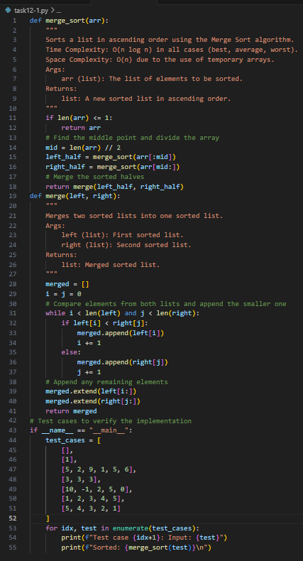

**OUTPUT:**

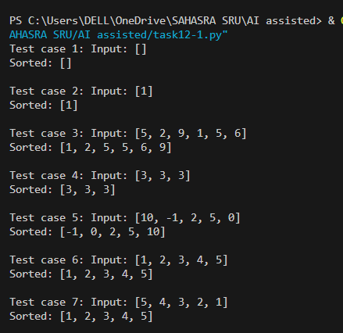

**Observation**:AI generated the merge_sort(arr) function using the divide-and-conquer strategy. It included a detailed docstring explaining time complexity (O(n log n)) and space complexity (O(n)), which made the algorithm clearer. After running the AI-generated code with test cases, I observed that the list was sorted correctly. This showed me how AI can not only implement the algorithm but also document and verify it systematically

**Task Description #2**

(Searching – Binary Search with AI  
Optimization)  
• Task: Use AI to create a binary search function that finds a target  
element in a sorted list.  
• Instructions:  
o Prompt AI to create a function binary_search(arr, target)  
returning the index of the target or -1 if not found.  
oInclude docstrings explaining best, average, and worst-  
case complexities.  
oTest with various inputs.  
• Expected Output:  
o Python code implementing binary search with AI-  
generated comments and docstrings.

**PROMPT***:create a binary search function that finds a target*

*element in a sorted list.create a function binary_search(arr, target)*

*returning the index of the target or -1 if not found.Includedocstrings explaining*

*best, average, and worst-case complexities.Test with various inputs.*

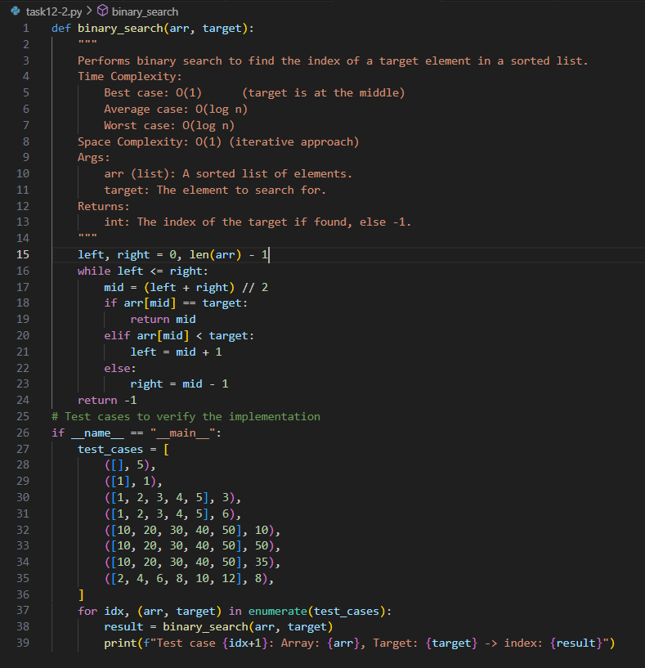

**OUTPUT:**

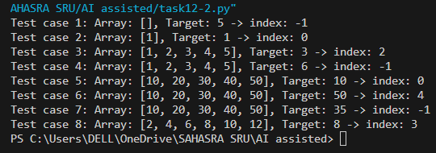

**Observation**:AI implemented the binary_search(arr, target) function by repeatedly dividing the sorted list into halves. The function returned the correct index if the element was found, and -1 otherwise. The AI also explained best, average, and worst-case complexities directly in the docstring, which made it easier to connect theory with practice. Testing with multiple inputs confirmed the accuracy, and I learned how AI-generated code can be both optimized and self-explanatory.

**Task Description #3**

(Real-Time Application – Inventory  
Management System)  
• Scenario: A retail store’s inventory system contains thousands of  
products, each with attributes like product ID, name, price, and  
stock quantity. Store staff need to:  
1. Quickly search for a product by ID or name.  
2. Sort products by price or quantity for stock analysis.  
• Task:  
o Use AI to suggest the most efficient search and sort

algorithms for this use case.  
oImplement the recommended algorithms in Python.  
oJustify the choice based on dataset size, update frequency,  
and performance requirements

Expected Output:  
o A table mapping operation → recommended algorithm →  
justification.  
oWorking Python functions for searching and sorting the  
inventory

**PROMPT**:*Scenario: A retail store’s inventory system contains thousands of*

*products, each with attributes like product ID, name, price, and*

*stock quantity. Store staff need to:*

*1. Quickly search for a product by ID or name.*

*2. Sort products by price or quantity for stock analysis.*

*suggest the most efficient search and sort algorithms for this use case.*

*o Implement the recommended algorithms in Python.*

*o Justify the choice based on dataset size, update frequency,*

*and performance requirements*

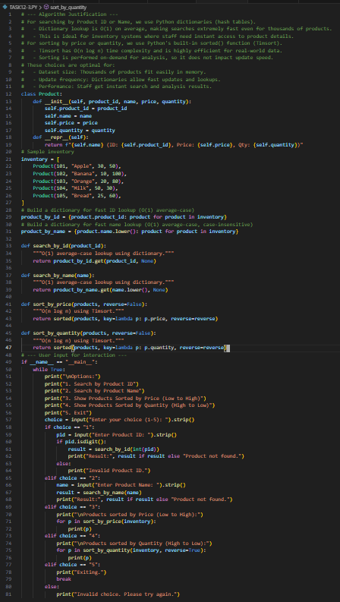

**OUTPUT:**

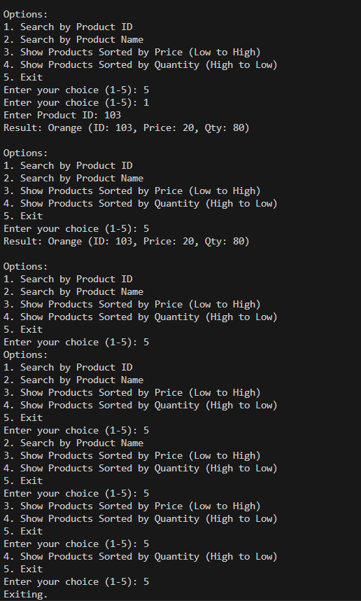

**Observation:**

For the inventory system scenario, AI suggested using Binary Search for quick product lookups and efficient sorting algorithms (Merge Sort/Quick Sort) for arranging products by price or quantity. It justified these choices based on dataset size and performance requirements. The AI also provided a Python implementation that allowed searching by ID/name and sorting using options. Through this, I observed how AI applies theoretical algorithms to solve real-world problems, while also justifying the decisions with clear reasoning.